Beauty Month #1
2019
Celebrating natural beauty , art and human design!
A Sample of Events & Activities  Beauty is a great path to community building and maintaining well-being. The And Beauty for All campaign encourages libraries to host a month of beauty celebrations. Here are some ideas for beauty-related activities to jumpstart your plan. | 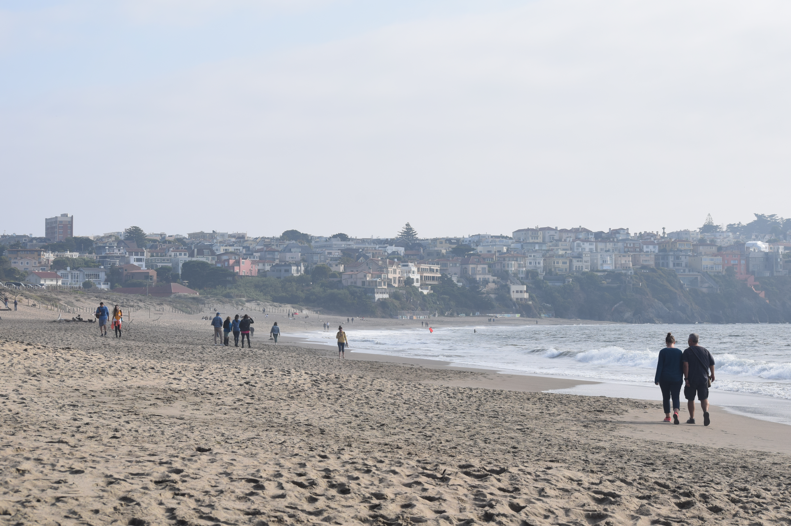
Sunday | Monday | Tuesday | Wednesday | Thursday | Friday | Saturday
 |  | 1 | 2 | 3 | 4 | 5
 |  | Open the beauty video contest | Open the photography contest | Plan Exhibit of books about beauty
6 | 7 | 8 | 9 | 10 | 11 | 12
 |  | Open the essay contest | Open the visual art contest
13 | 14 | 15 | 16 | 17 | 18 | 19
 |  |  | Close the photography contest | Open exhibit of beauty books with reception
20 | 21 | 22 | 23 | 24 | 25 | 26
 |  | Close the beauty video Contest | Close the visual arts contest | Feature photo winners
27 | 28 | 29 | 30 | 31
 |  | Announce the video contest winner | Feature visual art winners | Show winning videos
For additional inquiries about And Beauty for All please visit www.andbeautyforall.org or email jodg@comcast.net.

Beauty Month #2
2019
Celebrating natural beauty , art and human design!
A Sample of Events & Activities  Beauty is a great path to community building and maintaining well-being. The And Beauty for All campaign encourages libraries to host a month of beauty celebrations. Here are some ideas for beauty-related activities to jumpstart your plan. | 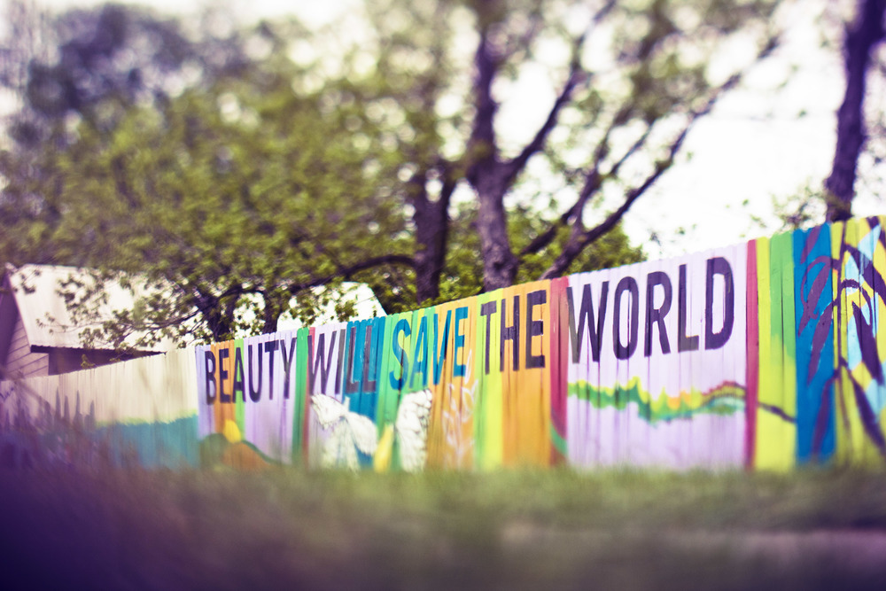
Sunday | Monday | Tuesday | Wednesday | Thursday | Friday | Saturday
 |  | 1 | 2 | 3 | 4 | 5
 |  | Close essay contest |  | Feature Art by Local Artists (Visual, Audio) |  | Gardening at the Library: Potted flowers
6 | 7 | 8 | 9 | 10 | 11 | 12
Local gardens walk |  | Speaker on local architecture |  | Speaker on local parks and nature
13 | 14 | 15 | 16 | 17 | 18 | 19
Visit a city park |  | Keynote speaker—from community |  |  |  | Rock Painting Event: Decorate using the rocks
20 | 21 | 22 | 23 | 24 | 25 | 26
 |  | Read winning essays |  | Speaker on local art history |  | Watercolor Painting Event
27 | 28 | 29 | 30 | 31
Visit a state park |  | Announce the Video Contest Winner |  | Show winning videos
For additional inquiries about And Beauty for All please visit www.andbeautyforall.org or email jodg@comcast.net.

How to use this calendar:

Please use these calendars as a guide for planning your celebratory month(s) of beauty.

Here are some of the ideas in the calendar:
BEAUTY VIDEO CONTEST—for high school students—ask for submission of short video (5 minutes or less) on beauty in your community.
BEAUTY PHOTO CONTEST—for all ages. Invite patrons to submit beautiful photos they have taken to be put up in an exhibit. A juried photography exhibit—display beautiful photographs of your town or nearby wonders!
BOOK EXHIBIT. Set up a display of books the library has on beauty and especially on local points of interest. An adult books exhibit featuring books about beauty found in the library, with a focus on where to find local beauty. Create a similar exhibit for Young Adults and Teens.
ESSAY CONTEST. For high school and college students. Encourage students to write essays on such topics as “What beauty means to me,” or “Where I find beauty in my neighborhood.” Be creative with possible topics.
VISUAL ART CONTEST—for elementary and middle-school students—painting, drawing, finger painting creation of montages etc.

In this model, we preface Beauty Month with a preparatory or introductory month. The first month focuses on encouraging people to create and submit beauty-related projects. This creates material to display during the latter parts of month #1 and the entirety of month #2. The second month is for the main festivities. This includes hosting events with a variety of speakers who are knowledgeable in different types of beauty as well as community-building events.

Additional Recommendations: (from the And Beauty for all July 2018 Newsletter)

Raise funds for the event by having contests, etc. sponsored by a local business/businesses.
A concert featuring songs about beauty, including singalongs of America the Beautiful and This Land is Your Land.
A survey to determine how your local residents view beauty and what they think can be done to make their community more beautiful.
Partnerships with local media to do stories about local beautification efforts.
A city proclamation endorsing And Beauty for All Day (October 2) and committing your community to greater beautification efforts. See https://www.andbeautyforall.org/new-page-3/
The number of ideas are limited only by planning time and resources. None should be expensive, and the activity is likely to lead to wider citizen appreciation of the library. See https://www.andbeautyforall.org/simple-things-you-can-do/
It may be possible to find business or foundation grants to carry out this project.

